RHEL 8 LVM based Installation

Tasks

1. Boot up a RHEL 8 virtual machine and perform a custom installation using the graphical installer, making sure to select 'LVM' as the partitioning scheme for the root (/) partition.

ANS:

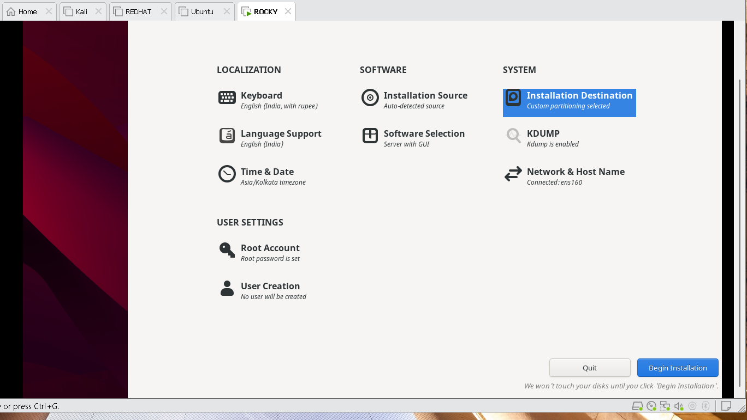

2. Inside your RHEL 8 system, use the 'lsblk' and 'vgs' commands to verify that your root partition is managed by LVM and note down the Volume Group and Logical Volume names.

ANS:

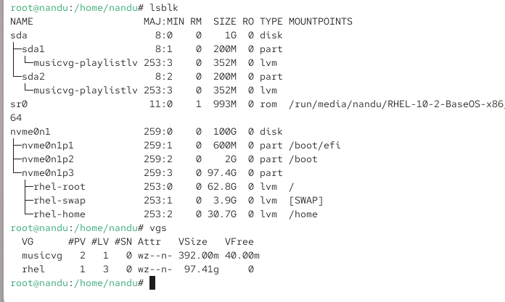

Volume Group = musicvg and rhel
Logical Volume = swap, home, root, playlistlv

3. Add a new virtual disk to your RHEL 8 VM, then use 'pvcreate', 'vgextend', and 'lvextend' to increase the size of your existing root Logical Volume by at least 1GB, and resize the filesystem to use the new space.Use 'df -h' before and after to confirm the size change.

ANS:

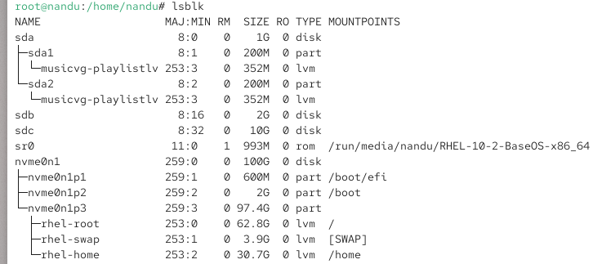

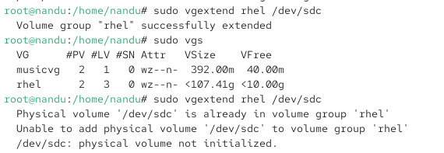

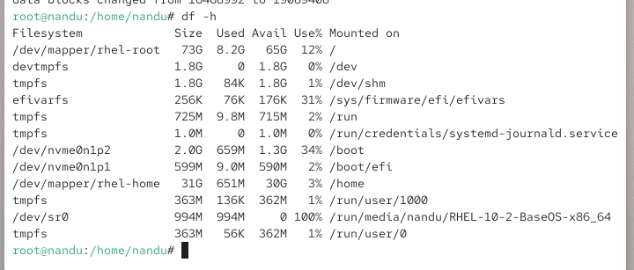

4.Create a new Logical Volume called 'musicdata' of 500MB in your existing Volume Group, format it with ext4, mount it at /mnt/music, and add an entry to /etc/fstab so it mounts automatically on boot. Use only command-line tools (no GUI) for this task.

ANS:

